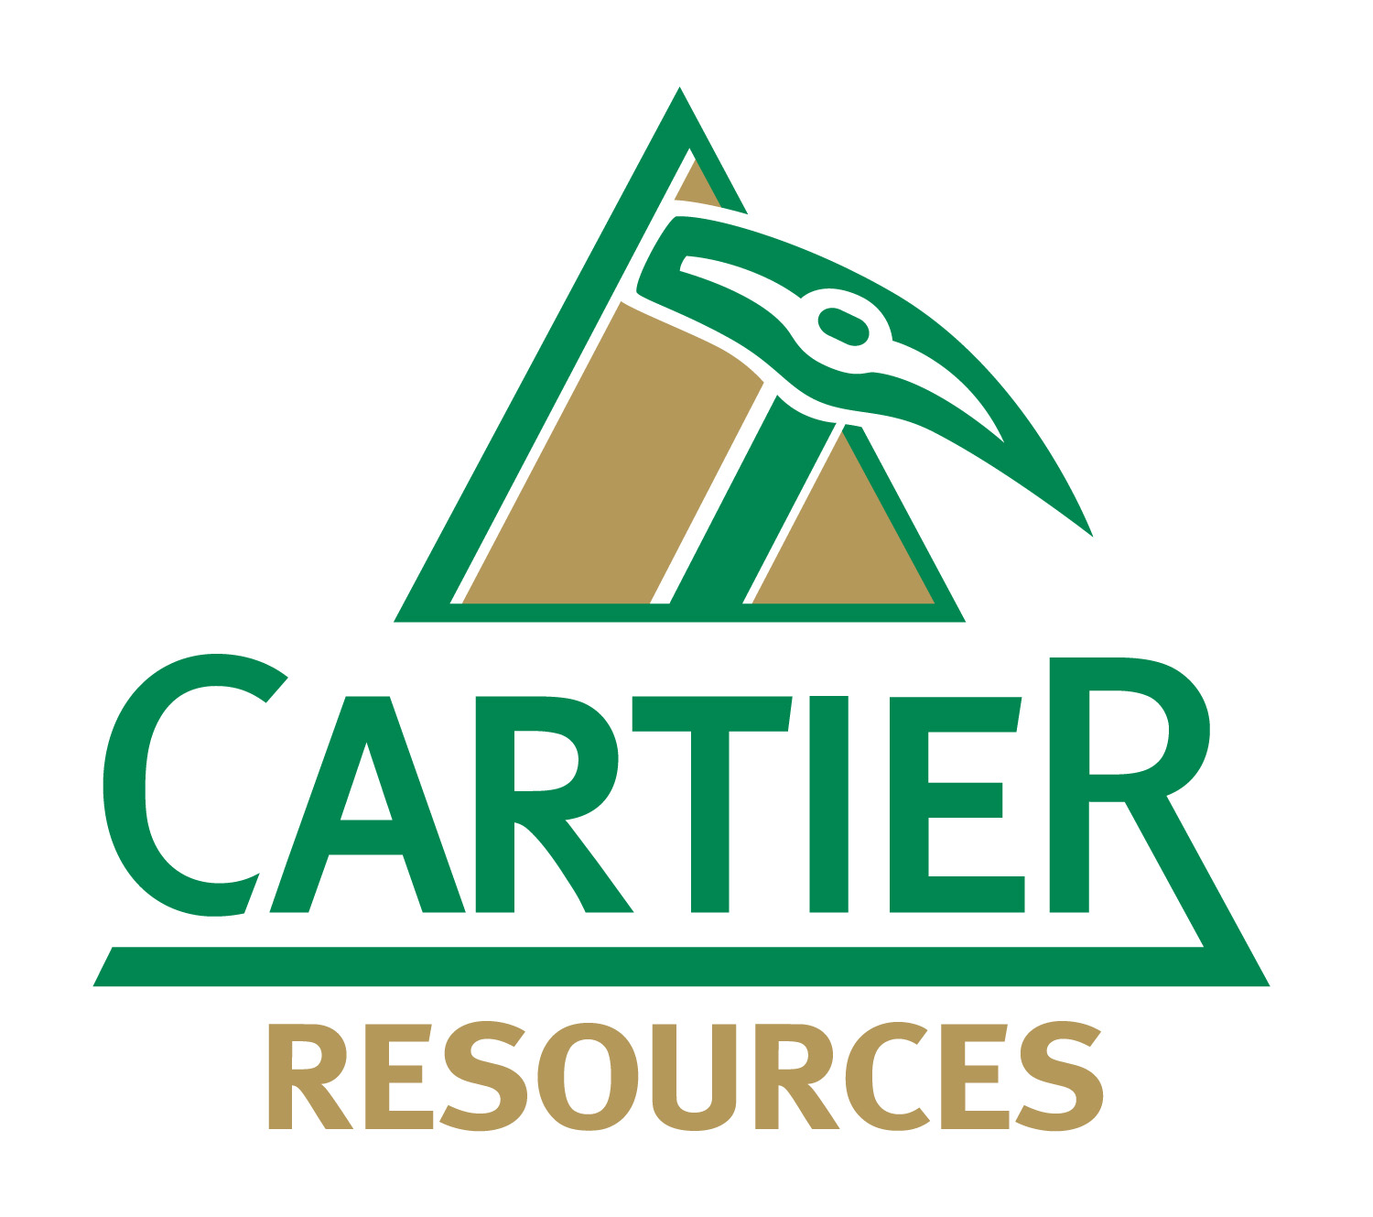
CARTIER ENGAGES PARADOX TO PROVIDE INVESTOR RELATIONS SERVICES

Val-d’Or, Canada, August 02, 2019 – Cartier Resources Inc. (TSX Venture Exchange: ECR) (“Cartier”) is pleased to announce that, effective August 1, 2019, it has engaged Relations Publiques Paradox Inc. (“Paradox”) to provide investor relations services to Cartier. Paradox is a Montreal based investor relations consultancy firm that has been in business for over 15 years. Paradox has represented a number of public companies through its extensive network and experience in the capital markets.

Paradox will increase visibility towards the financial community by direct introduction, marketing to the investment community to identify potential investors, use of Paradox’s proprietary database and contacts for marketing purposes, organizing presentations with interested parties, and handling of incoming calls from shareholders and potential investors. Paradox’s extensive experience and large network provides full-service approach to investor relations and it will provide creative, effective results-driven investor relations programs for Cartier.

The agreement has a term of 12 months from the date of its signature and may be terminated at any time without charge by either party by giving 30 days’ notice in writing. Paradox will be paid a monthly fee of $7,500 and will be granted an option to acquire 300,000 common shares of Cartier at a price of $0.14 per share for a period of five years, in accordance with the current stock option plan and Policy 3.4 of the TSX-V. The Investor Relations Agreement as well as the professional engagement fees and granting of stock options is subject to TSX Venture Exchange approval,

The directors of Paradox are, Jean‐François Meilleur, acting president, Carl Desjardins and Karl Mansour. The company 9244‐2946 Québec inc., under direct control by Gestion Jean‐François Meilleur inc., Gestion Carl Desjardins inc. and Gestion Karl Mansour inc., are majority shareholders of Paradox. Jean‐François Meilleur, Carl Desjardins and Karl Mansour will be the persons providing the services to Cartier. Paradox offices are situated at 1178, Place Phillips, suite 250, Montréal, Québec.

This press release is not an offer or a solicitation of an offer of securities for sale in the United States. The securities have not been and will not be registered under the U.S. Securities Act of 1933, as amended, and may not be offered or sold in the United States absent registration or an applicable exemption from registration.

The common shares of Cartier Resources Inc. are listed on the TSX Venture Exchange under the symbol “ECR”.
- 30 -
For more information, please contact:  Philippe Cloutier, P.Geo.  President and CEO  Telephone: 819 856-0512  philippe.cloutier@ressourcescartier.com  www.ressourcescartier.com | Investor Relations:  Relations Publiques Paradox  514 341-0408

Neither the TSX Venture Exchange nor its regulatory services provider accepts responsibility for the adequacy or accuracy of this press release.

